DSA06 Data Handling and Visualization
R.No: 4 Reg. No: 192324305 Name: AYESHA SIDDIQA S
T1. Connect and check [3]
Open Tableau Public, connect to your CSV file (Text file), and set Month as a Date. Report the number of rows, which fields are dimensions and which are measures, and the total Sales and total Profit.
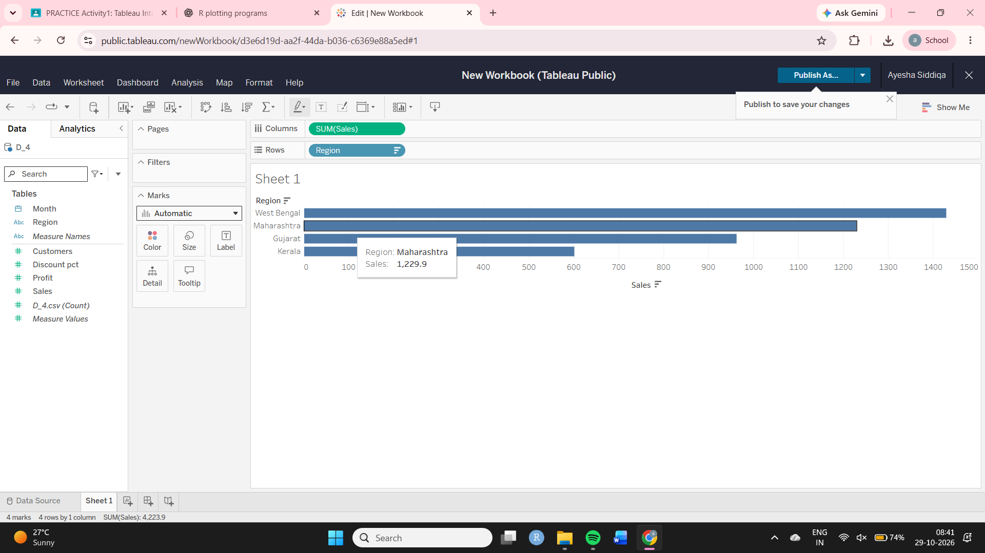
T2. Bar chart [4]
Build a bar chart of Sales by Region, sorted from highest to lowest, with labels on the bars. Name the top and the lowest region and give the top region&#39;s share of the total sales (%).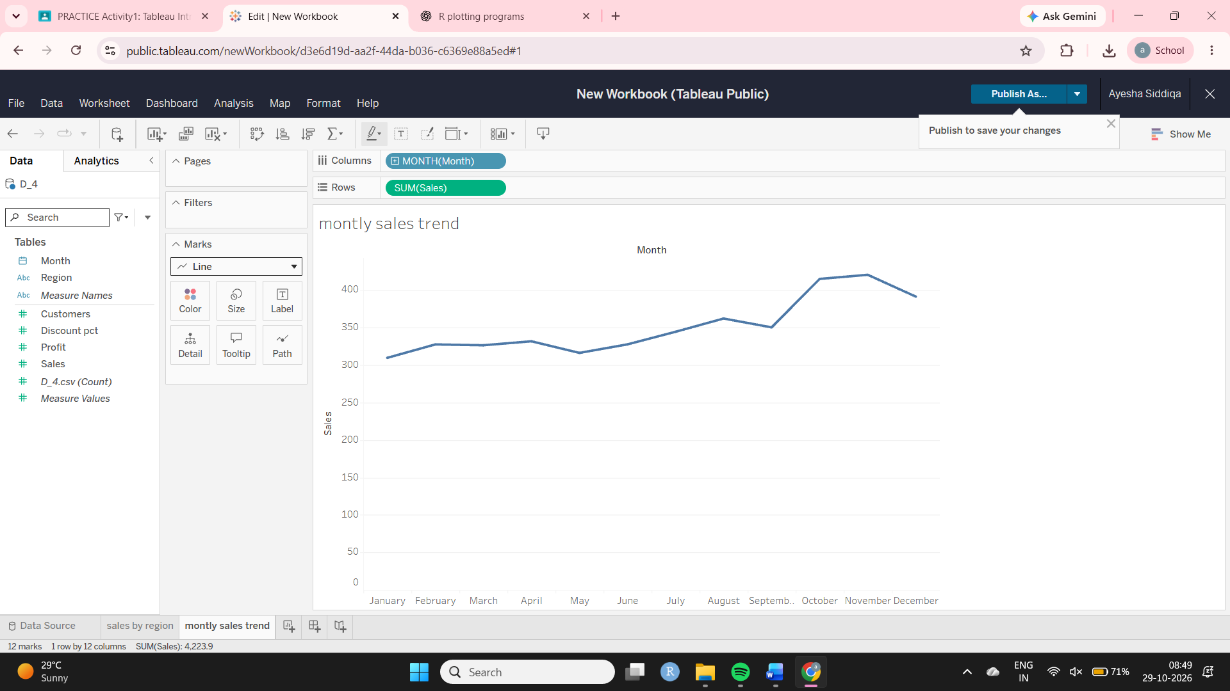
T3. Line chart and trend [5]
Build a line chart of total Sales by Month. Add a linear trend line (Analytics pane) and a 3-month moving average (right-click SUM(Sales) &gt; Quick Table Calculation &gt; Moving Average). Report the peak month and its value, the moving average at June, and the trend slope per month (from Describe Trend Model)
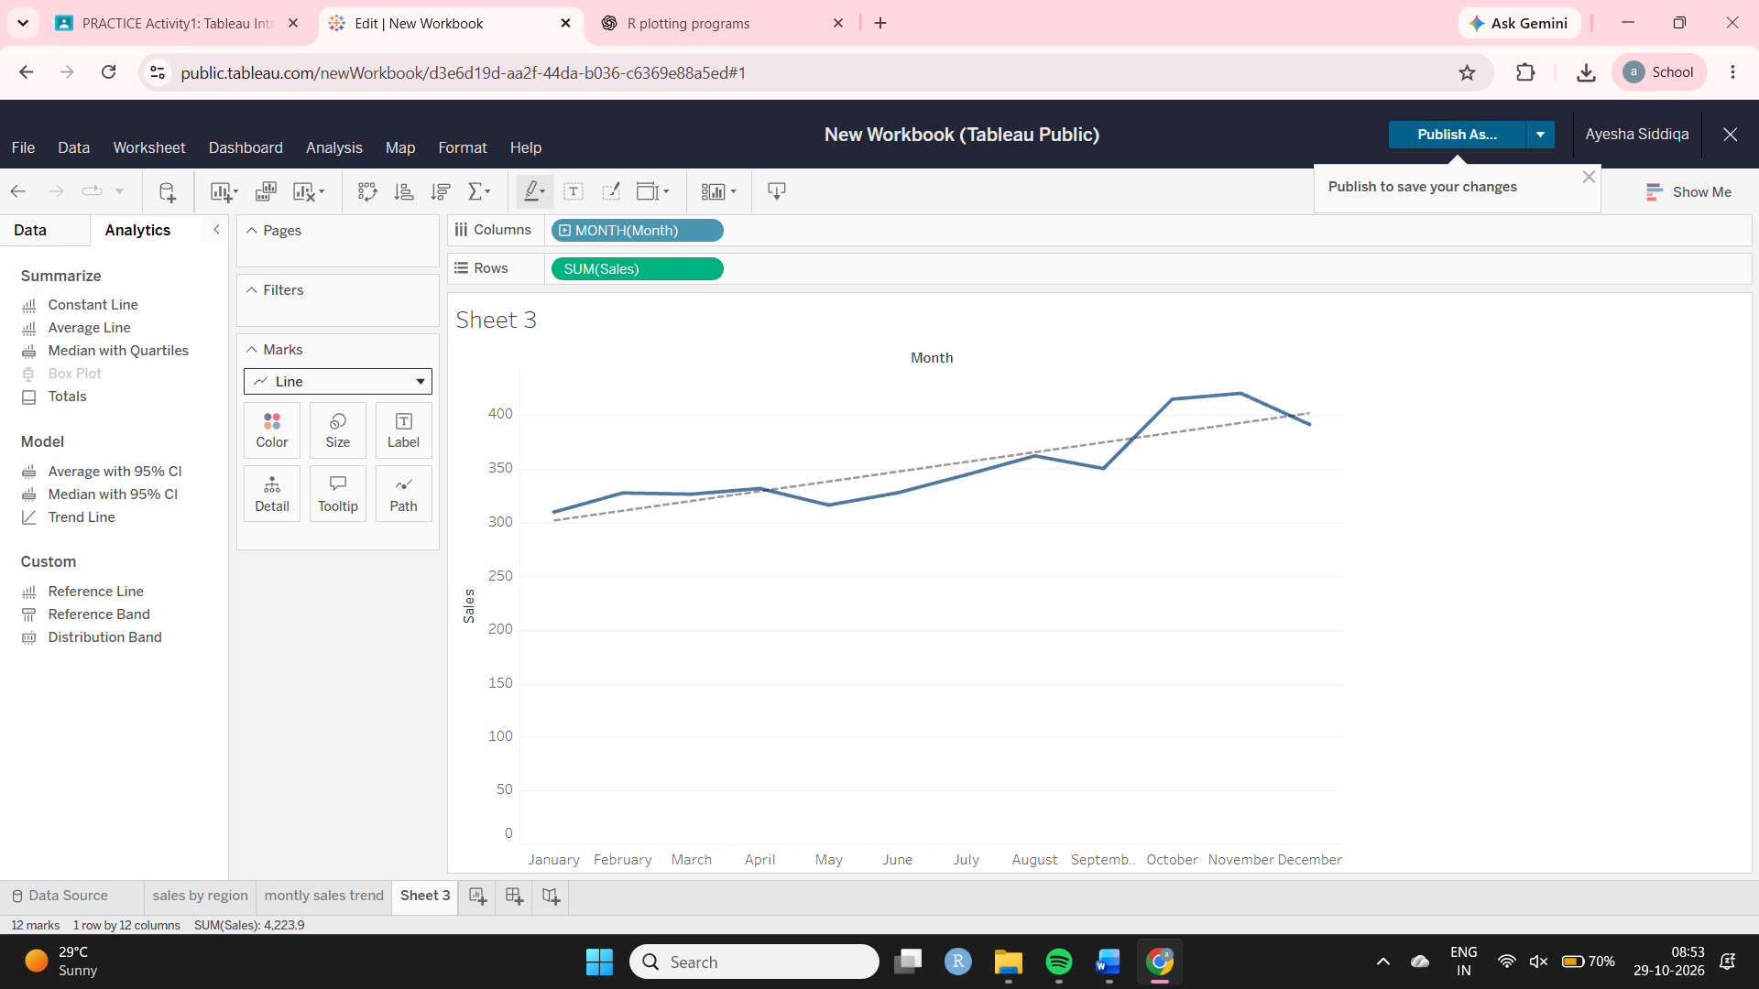
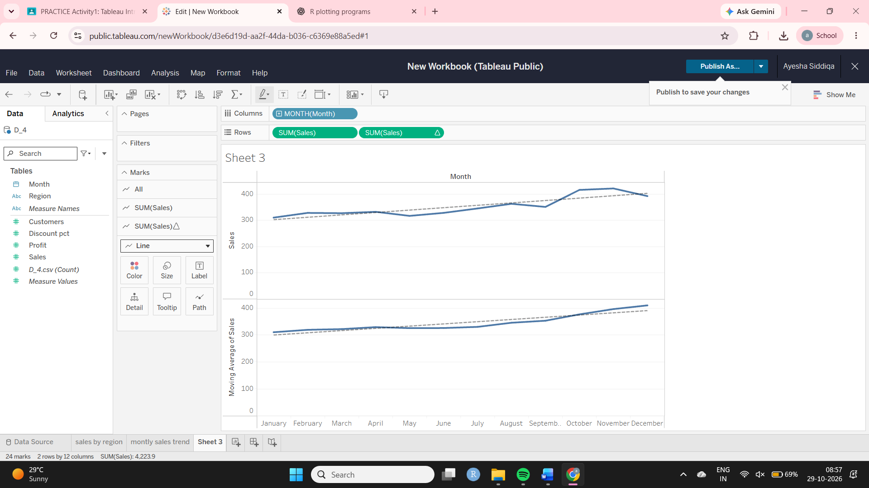
T4. Scatterplot [4]
Build a scatterplot of Discount_pct (columns) against Profit (rows), one point per row (turn off aggregation), coloured by Region, with one overall trend line. Report the slope, r (the square root of R-squared with the sign of the slope) and say in one sentence what it means for the business.
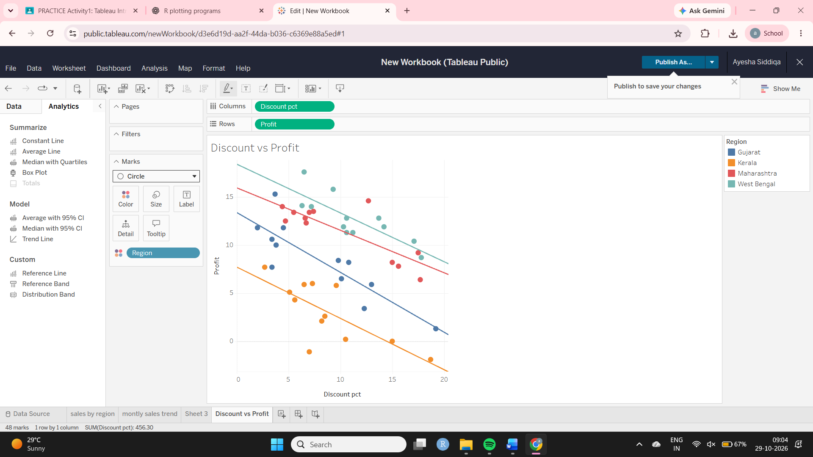
T5. Filled map [3]
Build a filled map of Profit by Region (double-click Region; Tableau should recognise Indian states). Name the region with the lowest total Profit and compute its profit margin (Profit / Sales, %).
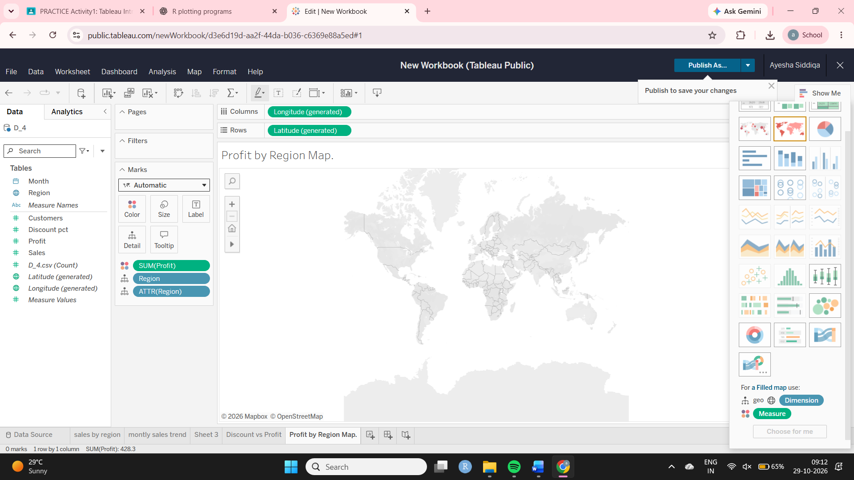
T6. Dashboard with a filter [4]
Place the bar chart, the line chart and the map on one dashboard and make the bar chart a filter (Use as Filter). Click the region with the SECOND-highest sales and report that region&#39;s total Sales, total Profit and profit margin (%). Publish to Tableau Public and paste the link.
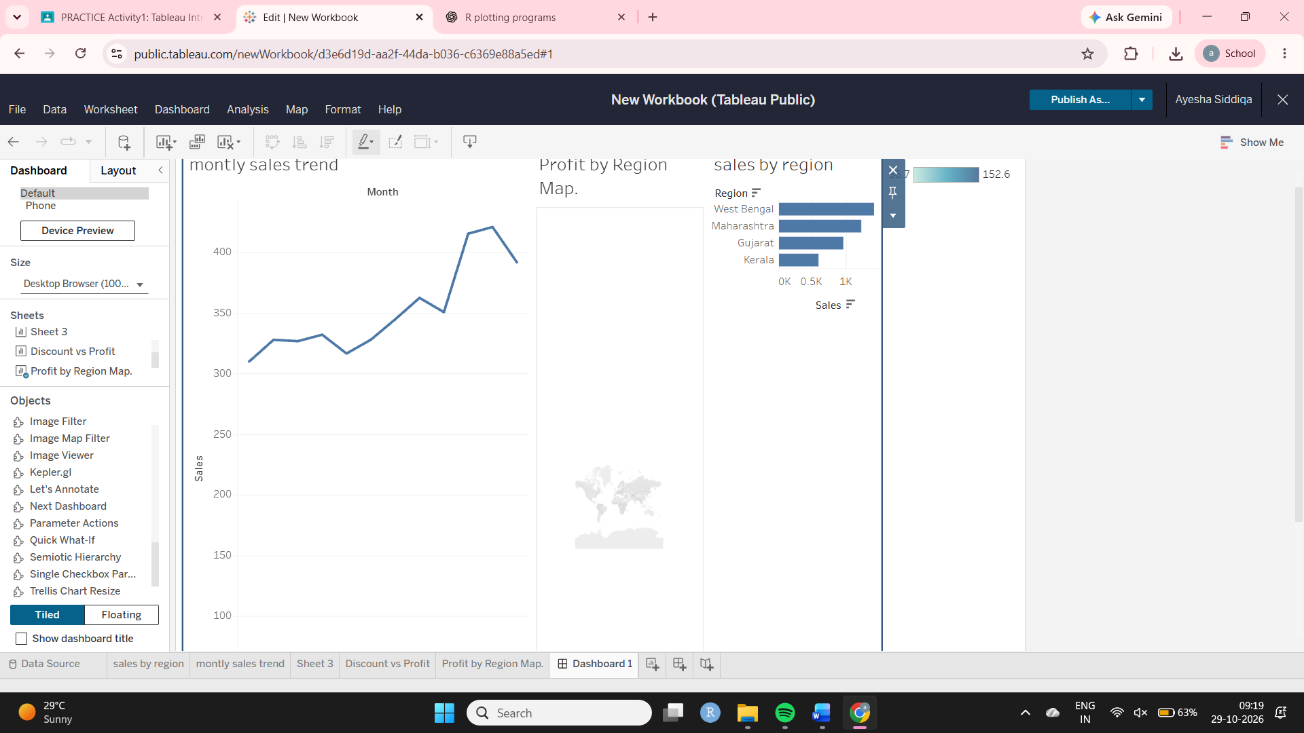
T7. Compare with R [2]
Write two real differences between doing the T3 line chart in Tableau and doing it in R (ggplot2).
Tableau | R ggplot2
1. Tableau creates charts mainly using a drag-and-drop interface with Rows, Columns, Marks and filters. | ggplot2 creates charts using R code and functions such as ggplot(), aes() and geom_line().
2. Tableau supports interactive dashboards and filter actions directly through its interface. | ggplot2 charts are static by default; extra packages such as plotly or shiny can add interactivity.

